Chapter One: Afghanistan

Before I retired from my business, I’d get up every morning and, after prayer and meditation, watch the Today Show’s world news report:

*Four American soldiers were killed this morning in Kunar Province, Afghanistan, by an*

*Improvised Explosive Device when their Humvee struck…*

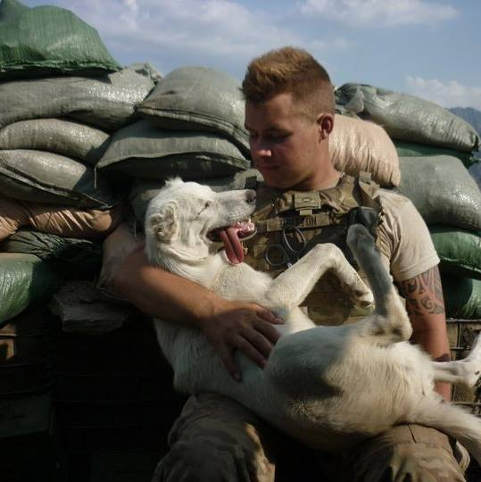

Brain shut down. Nothing to do but wait…

Our son Paul drove a Humvee in Kunar Province, Afghanistan, in 2011. Damn.

Powerlessness at the highest level. A father’s most horrific thinking kicks in.

Alone, sitting in my chair, candles lit on the mantle before Daffodil is up, Rae is away at school, locked in a raging battle with her dragons, one in particular she’d never completely slay, but would successfully contain, even dance with.

The dogs and cats are asleep, oblivious. My mind, white hot ffftt…

What to do with that?

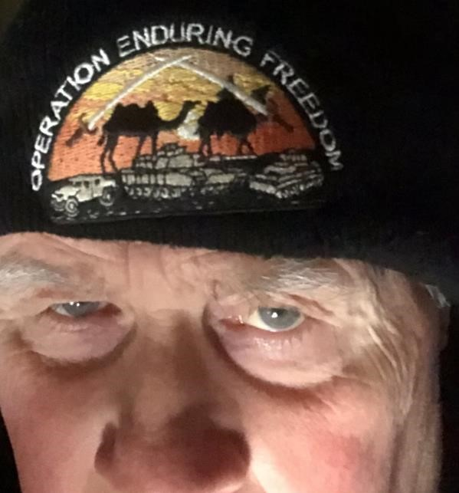

Nothing *to* do. Wait.

I am blessed enough to have found faith long before our boy left for combat, so prayer has become natural. That's my “go-to” action, so that’s naturally what I go to.

Even so, I am on the verge of losing it. Before that happens, a text comes from either Sergeant Babb or Watson: “He’s ok.” I’m able to breathe. This time. For a while. Until the next time.

Then my military-father brain goes to a lesser but still harsh level, knowing that four other sets of moms and dads are hoping against hope that the imminent knock on the door never comes. I know Babb and Watson won’t be texting those families. Those families will see a pair of soldiers in dress uniforms standing solemnly at attention on the steps at the front door.

Instead of simply moving through their days, the families of the fallen soldiers’ lives are shattered by their very personal, paralyzing news.

A firm “Tap Tap Tap” at their doors. Their lives will *never* be the same. Their legacies will never be what they’d hoped.

When Paul was in high school, we went to all of his wrestling matches and football games, whatever, but the one that stands out was the halftime in honor of fellow Riverside alum David Baker.

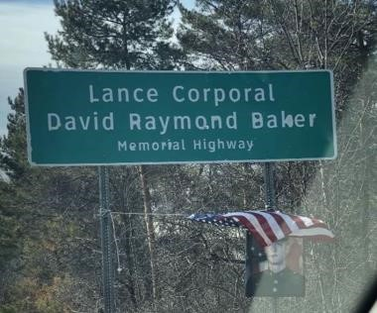

Riverside High School’s Lance Corporal David Baker’s family came to the honorary halftime gig. He had served in Enduring Freedom only 2 years before Paul served in the same operation. Corporal Baker has a highway sign right there on State Route 2 near Rt, 44 in Painesville.

But seeing this unfold from the warmth and comfort of my Lazyboy and experiencing the unimaginable loss of a child are two completely different things, so after I catch my breath and continue with prayers, I go about my day solemnly, until little by little the dread erodes. I shake off as much horror as possible.

My mind insulates me, protects me, and eventually forgets the other families and stops trying to imagine their faces. Then I almost begin to feel something closer to normal. After all, my boy is doing well. He’s okay… *This* morning… But still. We won’t feel anything like normal until he’s “*Home*.” Which he’s been for a while now, so that’s nice.

\*\*\*\*\*\*\*\*